Reformation 5 Doc DBQ Exercise
Today you will complete a DBQ exercise that is based on the following question:

“Evaluate the extent to which the Protestant Reformation challenged social and cultural norms in 16th century Western Europe”

Part One: Read/Mark Up Documents
Part 1 Directions: Please read/mark up the following 5 documents in no more than 10-15 minutes, as you would on the real DBQ. (You can use comments function or type directly into your google doc beneath each doc). Then proceed to part two.

Document 1
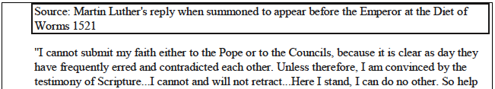
me God, Amen.”

Document 2
Hitherto we have been held as your poor serfs, which is pitiable, given that Christ has purchased and redeemed us with His precious blood, just as He has the Emperor. But it is not our intention to reject all authority. We will be obedient to all authority appointed by God in all fair and reasonable matters, and we do not doubt that as Christian lords you will release us from serfdom.
- Peasant Parliament of the Swabia region of Germany, to the Memmingen Town Council, from Articles of the Peasants of Memmingen, March 3, 1525, during the German Peasants’ Revolt.

The peasants forgot their place, violently took matters into their own hands, and are robbing and raging like mad dogs. It is clear that the assertions they made in their Twelve Articles were nothing but lies presented under the name of the Gospel. This is particularly the work of that devil, Thomas Müntzer, who rules at Mühlhausen. The peasants are not content with belonging to the devil themselves; they force and compel many good people to join their devilish league. Anyone who consorts with them goes to the devil with them and is guilty of all the evil deeds that they commit.
-Martin Luther, theologian, Against the Murdering, Thieving Hordes of Peasants, Wittenberg, May 1525, during German Peasants Revolt

Document 3
Source: The Second Book of Homilies, produced by bishops of the Church of England, authorized by Elizabeth I, 1562.

The husband ought to be the leader and author of love in cherishing and increasing concord. . . . But as for wives, they must obey their husbands, and cease from commanding, and perform subjection. For this surely doth nourish concord very much, when the wife is ready at hand at her husband’s commandment . . .

Document 4

Source: Report of Churchwardens in Gloucestershire, England, 1563

There is one Alice Prabury in our parish that useth herself suspiciously in the likelihood of a witch, taking upon her not only to help Christian people of diseases strangely happened, but also horses and all other beasts. She taketh upon her to help by the way of charming, and in such ways that she will tell nobody her sayings...

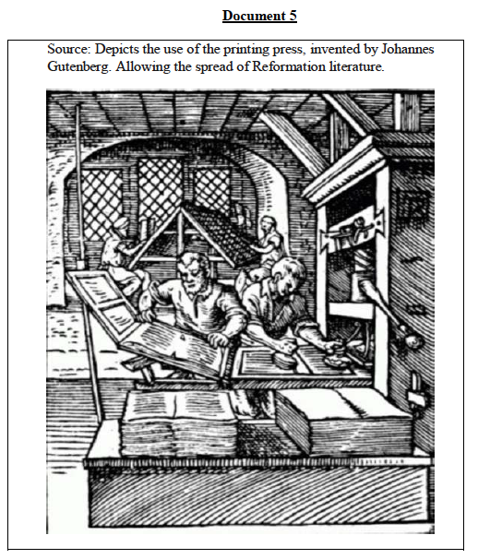

Part 2 Directions: Please produce a thesis and context using the hints you were given in class today. Then please choose THREE of the documents above to DESCRIBE, SUPPORT, and ANALYZE, showing how you could use them in your DBQ to earn points in all three ways.
(**Make sure your context and analysis are relevant, and your thesis complex!**)

- Your (Clear, Concise, Complete, Complex) Thesis

- Your (Relevant, Complete) Context

- Your Document Analysis- Please pick THREE of these documents and demonstrate your ability to DESCRIBE their relevant content, SUPPORT an argument and ANALYZE the context/production of the document to further support an argument.

Doc # _________
Describe its relevant content/idea that supports your thesis in 1 sentence or less:

Now explain how you would use it to SUPPORT your thesis:

Now demonstrate how you would FURTHER SUPPORT your thesis by analyzing something about the doc’s context/POV/purpose/audience that makes it an even stronger piece of evidence for your argument:

Doc # _________
Describe its relevant content/idea that supports your thesis in 1 sentence or less:

Now explain how you would use it to SUPPORT your thesis:

Now demonstrate how you would FURTHER SUPPORT your thesis by analyzing something about the doc’s context/POV/purpose/audience that makes it an even stronger piece of evidence for your argument:

Doc # _________
Describe its relevant content/idea that supports your thesis in 1 sentence or less:

Now explain how you would use it to SUPPORT your thesis:

Now demonstrate how you would FURTHER SUPPORT your thesis by analyzing something about the doc’s context/POV/purpose/audience that makes it an even stronger piece of evidence for your argument:

