Politics of the Gilded Age
- Gilded Age, 1870 to 1900
  - Background
    - The Gilded Age suggests that there was a glittering layer of prosperity that covered the poverty and corruption that existed in much of society.
    - Time of corruption, scandals in local, state and national government
    - Ostentatious wealth or conspicuous consumption
      - The wealthy lived extravagant lifestyles and considered themselves elitists.
      - The common people resented their snobbish attitudes and wealth.
      - There was a caste system in the U.S.
        - 1850: 19 millionaires
        - 1900: 4,000 millionaires
        - 1900: 75% of wealth, controlled by 10% of population.
- The Emergence of Political Machines
  - Political Machine
    - Organized group that controls a city’s political party
    - Give services to voters, businesses for political, financial support
  - Structure of Political Machine
    - Precinct captains, ward bosses, city boss
    - Many captains, bosses were 1st or 2nd generation Americans
    - Machines help immigrants with naturalization, jobs, housing
  - The Role of the Political Boss
    - Bosses paid by businesses, get voters’ loyalty, extend influence

    - Controls city jobs
    - Business licenses
    - Influences courts
    - Arranges building projects
    - Community services

  - Election Fraud and Graft
    - Machines use electoral fraud to win elections
    - Graft is the illegal use of political influence for personal gain
    - Machines take kickbacks, bribes to allow legal, illegal activities
  - William “Boss” Tweed
    - Corrupt political leader put New York City in debt
    - Kept Democratic Party in power in NYC called Tammany Hall
    - Formed the Tweed Ring
      - Bought votes, encouraged corruption, controlled NYC politics
      - Received large fees or kickbacks for interests from the Erie Railroad
      - Tweed Ring milked the city with false leases, padded bills, false vouchers, unnecessary repairs and over-priced goods
  - Thomas Nast
    - Cartoonist who exposed Tweed’s corruption
    - Tweed Ring fell and 1873 Tweed convicted of embezzlement
- National Politics
  - The Republicans
    - appealed to the industrialists, bankers, and eastern farmers.
    - They favored the gold standard (sound money) and high tariffs
    - Blue laws, regulations that prohibited certain activities people considered immoral.
  - The Democrats
    - attracted the less privileged groups.
    - such as northern urban immigrants, laborers, southern planters, and western farmers.
    - Supported soft money and silver coinage.
  - President Grant's Scandals
    - Crédit Mobilier
      - Phony construction company owned by stockholders of Union Pacific Railroad.
      - Hired Credit Mobilier to build the transcontinental railroad
      - Charged U.S. government nearly twice the actual cost of the project.
      - Bribed Congress to stop the investigation.
      - Largest scandal in U.S. history, led to greater awareness of government corruption.
    - Whiskey Ring
      - A group of President Grant’s officials imported whiskey
      - Used their offices to avoid paying taxes and cheated US treasury of millions.
  - President Garfield’s Assassination
    - Spoils System
      - Under patronage, political candidates would offer jobs in exchange for votes.
      - Republicans and Democrats had roughly the same number of supporters.
    - 1880 Election
      - Republicans were split into 3 factions.
        - Stalwarts defended the spoils system—Sen. Roscoe Conkling
        - Half-Breeds reform but still supported it– Sen. James Blaine
        - Independents opposed the spoils system.
      - Garfield wanted reforms. His VP was Chester Arthur, a Stalwart.
    - Assassination
      - July 2, 1881 Garfield was assassinated by a Stalwart who wanted Arthur as president.
      - Charles Guiteau: “I Am a Stalwart, and Arthur is President now!”
      - Led to VP Chester Arthur becoming President
      - Supported a change to the corrupt spoils system.
    - Pendleton Act (1883) or the Civil Service Act.
      - 1883 13,000 out of 130,000 federal govt. jobs became civil service exam positions.
      - 1900 100,000 out of 240,000 civil service federal govt. jobs.
      - Required candidates for Gov. positions to take a test to determine their qualifications.
  - President McKinley's Assassination
    - Been re-elected in 1900 and beginning his 2nd term when he was assassinated in 1901…
    - VP Theodore Roosevelt became President.
- Role of the Federal Government
  - From 1870-1900 Government. did very little domestically.
  - Main duties of the federal government.:

    - Deliver the mail.
    - Maintain a national military.
    - Collect taxes & tariffs.
    - Conduct a foreign policy.

  - Laissez Faire
    - An economic belief that opposes the government regulating business.
    - Supports economic system of capitalism
  - Capitalism
    - Economic system characterized by private property ownership
    - Individuals and companies compete for their own economic gain (Profit)
    - Capitalists determine the prices of goods and services.
    - Production and distribution are privately or corporately owned.
  - Socialism
    - Economic system based on cooperation rather than competition
    - Government controls production and distribution of goods.
    - Opposite of laissez faire and capitalism
Immigration and Urbanization
 | Old Immigrants | New Immigrants
Religion | Protestant | Catholic and Jewish
Birthplace | North/Western Europe | Southern/Eastern Europe
Reasons | Both escaping poverty, religious and political persecution
Destination | Moved to farms in the Midwest | Moved to cities in the Northeast
Occupation | Became farmers | Unskilled workers
- Nativist Reactions to the “New Immigrants”
  - Why did Old Immigrants resent New Immigrants?
    - Plot by European governments to unload their prisoners, mentally ill, and “inferior stocks”
    - Chinese worked for 5 years and left the U.S. with U.S. money
    - Employers would hire “scab” labor to replace workers if they had a “Labor Strike”
  - US Govt. restricts immigration with the following
    - Chinese Exclusion Act
      - Provisions
        - First law to restrict immigration.
        - Created 10-year moratorium on Chinese Immigration
        - Prohibited Chinese from becoming citizens
      - Reasons for the Law
        - Resentment and discrimination against the Chinese.
        - Taking away jobs from Nativists
        - Chinese immigration would be outlawed until the 1940s.
    - Ellis Island
      - Built in 1892 as the 1st “Immigration Center”
      - The goal was to “screen” immigrants coming from Europe.
      - Immigrants took physical examinations and were held at Ellis Island before they were released to the US mainland.
- Urbanization
  - Reasons for Growth of Cities

    - Near raw materials
    - Industrial areas
    - Transportation routes.
    - Opportunities in the job market.

    - In 1860, no American city could boast a million inhabitants.
    - 1890, New York, Chicago and Philadelphia had spurted past the million mark.
    - Industrialization leads to urbanization, or growth of cities
  - Immigrants Settle in Cities
    - Most immigrants settle in cities; get cheap housing, factory jobs
    - Americanization—assimilate people into main culture
      - Schools, voluntary groups teach citizenship skills
      - English, American history, cooking, etiquette
      - Ethnic communities provide social support
  - Migration from Country to City
    - Farm technology decreases need for laborers; people move to cities
    - Low Crop prices, new machinery, and corrupt railroads forced many to look for new jobs.
    - Many African Americans in South lose their livelihood
      - 1890–1910, move to cities in North, West to escape racial violence
      - Find segregation, discrimination in North too
      - Competition for jobs between blacks, white immigrants causes tension
  - Urban Problems
    - Housing
      - Working-class families live in houses on outskirts or boardinghouses
      - Later, row houses built for single families
      - Immigrants take over row houses, 2–3 families per house
      - Dumbbell Tenements—multifamily urban dwellings, are overcrowded, unsanitary
    - Transportation
      - Mass transit —move large numbers of people along fixed routes
      - By 20th century, transit systems linked city to suburbs
    - Water
      - 1860s cities have inadequate or no piped water, indoor plumbing was rare
      - Filtration introduced 1870s, chlorination in 1908
    - Sanitation
      - Streets: manure, open gutters, factory smoke, poor trash collection
      - Contractors hired to sweep streets, collect garbage, clean outhouses
      - By 1900, cities develop sewer lines, create sanitation departments
    - Crime
      - As population grows, thieves flourish and early police forces too small to be effective
    - Fire
      - Fire hazards: limited water, wood houses, candles, kerosene heaters
      - Most firefighters were volunteers, not always available
      - 1900, most cities have full-time, professional fire departments
      - Fire sprinklers, non-flammable building materials make cities safer
  - Cities provided job opportunities
    - Machine-made jobs
    - High wages
    - Ended monotony of the farm.
    - Job opportunities for Women
      - Teaching, domestic service, Women doctors, lawyers, journalists and social workers.
    - Women employment rose from 2.5 million in 1880 to 8 million in 1910.
  - Cities were attractive

    - Telephones
    - Bright lights and electricity.
    - Indoor plumbing
    - Sewage disposal

    - Offered beautiful parks, museums, libraries, churches, hospitals and schools.
    - Became the intellectual nerve center of the country.
  - Multi-cultural community
    - Nativists disliked immigrants because they would not assimilate into America.
    - Immigrants would stay segregated in their ethnic neighborhoods.
- Reform Movements in Reaction to Immigration and Urbanization
  - The Social Gospel Movement
    - Sought to apply the gospel teachings of Christ: charity and justice to society’s problems.
  - The Settlement House Movement
    - Settlement houses—community centers in slums, help immigrants
    - Run by college-educated women, they:
      - offered cultural events, classes, childcare, employment assistance, and health care.
      - provide educational, cultural, social services
      - send visiting nurses to the sick
      - help with personal, job, financial problems
    - Jane Addams founds Hull House with Ellen Gates Starr in 1889
Industrialization

- Economic Philosophies
  - Laissez Faire
    - Individuals should compete freely in the marketplace.
    - Own their own business and use their skills to make profit for themselves.
    - The market was not man-made or invented and no room for government in the market.
    - Government should allow for natural competition for the betterment of our society.
  - Capitalism
    - Economic system characterized by private property ownership
    - Individuals and companies compete for their own economic gain (Profit)
    - Capitalists determine the prices of goods and services.
    - Production and distribution are privately or corporately owned.
  - Socialism
    - Economic system based on cooperation rather than competition
    - Some Americans opposed capitalism and believed a socialistic economy would better suit the US because some capitalists were corrupt.
    - Government controls production, sets wages, prices and distributes the goods.
    - Opposite of laissez faire and capitalism
- Factors for Industrialization
  - Labor force (immigrants)
    - Immigrants from Europe
      - Immigrants provided the labor force for industrial expansion of the US.
      - They also became the customers who in return bought the items produced.
  - Natural Resources
  - Capital (gold, silver and banking)
  - US Government support
    - Morrill Tariff Act (1862)
      - To protect and encourage American industry
    - National Banking System (1863)
      - To stimulate the economy and set up a banking system,
      - Significant step towards a unified, national banking system
      - Replaced by the Federal Reserve in 1913.
    - Morrill Act (1862)
      - Congress provided grants of public lands to the states for support of education.
      - “Land-grant colleges”
    - Land Grants to Railroads
      - Govt. donated land to RR companies to encourage growth of railroads.
      - US Govt. donated approx. 160 million acres of land
  - Desire: Creative inventors and industrialists

    - Patents
      - 1790s 276 patents issued.
      - 1990s 1,119,220 patents issued.
      - Gave an inventor the right to make and sell an invention.
    - Bessemer Process
      - In 1856, Henry Bessemer devised a way of converting iron into steel on a large scale.
      - Blowing air through molten iron in a furnace in order to burn off the excess carbon.
      - His invention revolutionized the Industrial Age.
      - New Uses for Steel
        - Steel used in railroads, barbed wire, farm machines
        - Changes construction: Brooklyn Bridge; steel-framed skyscrapers
        - Skyscrapers revolutionized the building industry (Build Up, Not Out)
    - Thomas Alva Edison
      - Edison Inventions helped to shape modern society
      - More than 1,000 inventions patented
        - Light bulb
        - Phonograph
        - Starter for automobiles that eliminated hand crank
        - New York City first city to powered by electricity
        - The motion picture camera and projector
      - First used “hello” as phone greeting
    - Alexander Graham Bell
      - Telephone (1876)
    - Wilbur and Orville Wright (1903)
      - Airplane
    - Henry Ford
      - Model T Automobile
    - New Stores
      - Specialty stores----sold single line of goods
      - Department stores---combined specialty stores
      - Chain stores---stores with branches in cities
      - Mail catalog stores
  - Transportation System
    - 1st Transcontinental Railroad
      - May 10, 1869 at Promontory, Utah
      - “The Wedding of the Rails”
      - Central Pacific and Union Pacific
    - Expansion of Railroads
      - 1869, 30,000 miles of track
      - 1900, 200,000 miles of track
      - Distribution System to the marketplace
      - Symbol of growth
    - What helped the railroad industry prosper?
      - Bessemer Process
      - Westinghouse Air Brakes
      - Steel Rails
      - Standard Gauge
- Business Organizations
  - Conglomerate
    - Group of unrelated business owned by a single corporation. Still used today.
  - Pool
    - Competing companies that agree to fix prices and divide regions among members so that only one company operates in each area. Outlawed today.
  - Trust (Monopoly)
    - Companies in related fields agree to combine under the direction of a single board of trustees, which meant that shareholders had no say. Outlawed today.
  - Holding Company
    - Company buys controlling amounts of stock in related companies, becoming the majority shareholder, and holding considerable say over each company's operations. Outlawed today.
  - Vertical Integration
    - Definition
      - You control all phases of production from the raw material to the finished product
    - Advantages Vertical Integration
      - You are always in control of supply of the products you need
      - In control of labor cost, land/resources
  - Horizontal Integration
    - Buy out your competition until you have control of a single area of industry
- Government Regulations
  - To regulate means the US Government would make laws to oversee, adjust, fine tune and correct the unfair business tactics in industry and big business. Not take over or control it because that would violate laissez faire.
  - Granger State Laws
    - State representatives passed state laws regulating railroad prices in 18 states.
  - Munn v. Illinois (1876) -Supreme Court decision
    - Stating that “states” had the ability to regulate private property if it affected public interest.
  - Wabash Case (1886) -Supreme Court decision
    - Declared that it was unconstitutional for states to regulate interstate commerce.
    - Showed need for Federal regulation of interstate commerce.
  - Interstate Commerce Act (1887)
    - Congress passed Interstate Commerce Commission (ICC).
    - U.S. government regulated interstate trade within the country.
    - End RR corruption of charging high prices to ship goods and rebates/kickbacks were illegal.
  - Sherman Antitrust Act (1890)
    - Law which made trusts/monopolies illegal or any business that prevented fair competition.
  - Business Tactics
    - Extortion
      - Forced against your will
    - Rebates
      - discount or refund on “freight charges”
    - Drawbacks / Kickbacks
      - Standard Oil gave certain railroads all its shipping business if it agreed to charge Standard Oil 25% to 50% less than its competitors
    - Buyouts
      - Larger corporations forced smaller businesses to sell out
    - Small businesses complained “monopolies” eliminated fair competition
- Businessmen of the Gilded Age
  - Entrepreneur
    - A person who organizes, operates, and assumes the risk for a business venture
  - “Robber Barons”
    - Business leaders built their fortunes by stealing from the public.
    - They drained the country of its natural resources.
    - They persuaded public officials to interpret laws in their favor.
    - They ruthlessly drove their competitors to ruin.
    - They paid their workers meager wages and forced them to toil under dangerous conditions.
  - “Captains of Industry”
    - The business leaders served their nation in a positive way.
    - Increased the supply of goods by building factories.
    - Raised productivity and expanded markets.
    - Created jobs that enabled Americans to buy new goods and raise their standard of living.
    - Created museums, libraries, and universities, many of which still serve the public today.
  - Andrew Carnegie
    - Captain of Industry
      - Monopolized the steel industry
      - Rags to riches story---came from Scotland very poor.
      - Used Bessemer Process to develop a better way to produce high quality cheap steel
      - Used Vertical integration.
    - Philanthropy
      - The effort to increase the well-being of humankind, as by charitable aid or donations.
    - Philanthropist
      - Gave millions to colleges and libraries.
      - Stressed education as a means to better one’s self.
      - Carnegie Hall
    - “Gospel of Wealth” (1889).
      - It was the sacred duty of the wealthy to give back to society who has given to him.
      - Inequality is inevitable and good.
      - Wealthy should act as “trustees” for their “poorer brethren.”
  - John D. Rockefeller
    - Captain of Industry
      - Came from a wealthy family
      - Formed the first modern corporations in the oil industry Standard Oil
      - Was the first billionaire in the U.S. by 1900.
      - Used Vertical and Horizontal Integration to gain a monopoly in the oil business.
    - Philanthropist
      - Gave millions of his money to hospitals and colleges.
      - University of Chicago
      - Spellman College
      - National Parks
    - Robber Barron
      - Controlled the RR by forcing them to pay him rebates because of the volume of business he gave them.
      - Ruthless business man: “Pay no man a profit”
      - Dictated to the U.S. Government to protect big business---- laissez faire
      - Hated by many because he had too much control over the oil industry
      - Some believed he was corrupt because he took away the right to compete
      - Big business, monopolies controlled Congress through bribery.
  - Cornelius Vanderbilt
    - Captain of Industry
      - Formed a steamship company in 1829
      - 1849 established steamship carrying people from NYC to San Fran. during gold rush
      - Leading U.S. steamship owner, nicknamed “The Commodore”
      - Gained control of the Hudson River Railroad
      - After Civil War Vanderbilt bought most railroad lines from New York to Chicago
      - 1877, controlled 4,500 miles of railroads
    - Philanthropist
      - donated $1 million to Vanderbilt University
- Industrialization Effects Society
  - Social Darwinism
    - British economist, Herbert Spencer.
    - Advocate of laissez-faire.
    - Adapted Darwin’s ideas from the “Origin of Species” to humans.
      - Belief that there was a natural upper class and lower class.
      - “Survival of the fittest”
      - Belief that in the economic world the strongest companies will survive
  - Darwinism applied to Business
    - Social Darwinists believed that companies struggled for survival in the economic world and the government should not tamper with this natural process.
    - The fittest business leaders would survive and would improve society.
    - Belief that hard work and wealth showed God’s approval and those that were poor were lazy and naturally a lower class.
  - Corporations as Entities
    - 14th Amendment
      - “All persons born in the U.S. are citizens of this country and the state they reside in. No state shall make or enforce any law which deprives any person of life, liberty, or property, without due process of law, nor deny to any person with its jurisdiction to the equal protection of the laws.”
      - Industrialists would use the 14th Amendment as a way to defend a corporation from the Sherman Anti-Trust Act.
  - Worker vs Employer
    - Impersonalization
    - Poor working conditions
    - Immigrants taking jobs
    - Decrease work day
    - Machines replacing workers
    - Child labor
    - Lack of job security
  - Working Families
    - In the 1880s, children made up more than 5 percent of the industrial labor force.
    - Children often left school at the age of 12 or 13 to work.
    - Girls sometimes took factory jobs so that their brothers could stay in school.
    - If an adult became too ill to work, children as young as 6 or 7 had to work.
    - Rarely did the government provide public assistance, & unemployment insurance didn’t exist
    - The theory of Social Darwinism held that poverty resulted from personal weakness.
    - Many thought that offering relief to the unemployed would encourage idleness.
  - The Work Environment
    - Division of Labor
      - Some owners viewed workers as parts of the machinery.
      - Unlike smaller and older businesses, most owners never interacted with workers.
    - Work Environment
      - Factory workers worked by the clock.
      - Workers could be fired for being late, talking, or refusing to do a task.
      - Workplaces were not safe.
      - Children performed unsafe work and worked in dangerously unhealthy conditions.
- Unionization
  - Definitions
    - Labor Union
      - Groups who organize to seek better wages and working conditions for wage earners.
    - Labor Strike
      - The unions' main method for having their demands met.
      - Workers stop working until the conditions are met.
    - Boycott
      - People refuse to buy a company's product until the company meets demands.
    - Scab Worker
      - New immigrants who would replace strikers and work for less pay. Often violence would erupt between strikers and scabs who were trying to cross picket lines to work.
    - Closed Shop
      - A working establishment where only people belonging to the union are hired.
      - It was done by the unions to protect their workers from cheap labor.
    - Black List or Black Balled
      - List of people disliked by business owners because they were leaders in the Union.
    - Collective Bargaining
      - Type of negotiation between an employer and labor union where they sit down face to face and discuss better wages, etc.
    - Yellow Dog Contracts
      - A written contract between employers and employees in which the employees sign an agreement that they will not join a union while working for the company
    - Lock Out
      - Owner would “lock out” workers who were trying to form a union and replace them with “scabs”.
  - Labor Unions
    - National Labor Union (1866)
      - Skilled, unskilled, farmers but excluded Chinese…
      - Cooperatives, 8 hr. work day, against labor strikes
      - Founded a political party in 1872
      - Involved in the Chinese Exclusion Act.
      - Lost election, faded away
      - Replaced by Knights of Labor.
    - Knights of Labor
      - All workers except Chinese
      - 8 hr. day, cooperatives, prohibition, end child labor
      - Several strikes won some wage gains 1885 to 1886
      - Unrealistic and vague goals
      - Loss of important strikes and failure of cooperatives
      - Haymarket Riot—1886
    - American Federation of Labor or AFL
      - Samuel Gompers, 1881
      - Skilled workers in separate unions.
      - Work within political system for change.
      - Closed shop and collective bargaining
      - Over 1 million workers joined and won several strikes
    - Socialists
      - Eugene V. Debs (Founder of the Socialist Party) in the U.S.
      - Overthrow the existing laissez faire and capitalistic
      - Believes in government ownership of business and capital (money, natural resources)
      - Government controls production, sets wages, prices and distributes the goods.
      - No profit or competition.
    - Industrial Workers of the World (IWW) or Wobblies (1905)
      - Led by William "Big Bill" Haywood
      - Filled primarily by unskilled workers, mostly of the low-wage, migratory type.
      - Organized on a class basis, welcoming all working people — including immigrants, minorities, women, and the unemployed.
      - Advocated the overthrow of the wage system, and putting workers in control of their own work lives through industrial organization.
- Major Strikes
  - The Great Railroad Strike of 1877
    - Railway workers protested unfair wage cuts and unsafe working conditions.
    - The strike was violent and unorganized.
    - President Hayes sent federal troops to put down the strikes.
    - From then on, employers relied on federal and state troops to repress labor unrest.
    - Debs and the American Railway Union
      - At the time of the 1877 strike, railroad workers mainly organized into various “brotherhoods,” which were basically craft unions.
      - Eugene V. Debs proposed a new industrial union for all railway workers called the American Railway Union (A.R.U.).
      - The A.R.U. would replace all of the brotherhoods and unite all railroad workers, skilled and unskilled.
  - Haymarket Square Riot
    - May 3, 1886, joining a nationwide strike for an 8 work day Chicago workers protested against the McCormick Reaper plant.
    - A riot broke out and Chicago police officers killed several protesters
    - To protest the killing, protesters planned a rally for May 4
    - During the protest, a bomb exploded 7 policemen were killed and civilians killed and injured
    - 8 anarchists were convicted of conspiracy to murder
    - This caused the public to look down on labor unions especially the Knights of Labor
  - Homestead Strike
    - 1892, Carnegie Steel workers strike over pay cuts
    - Management locks out workers and hires scab workers.
    - Violence erupted between strikers and scab workers.
    - Pinkerton Security called in to settle violence
    - Strikers ambush them and forced Pinkerton’s to walk the gauntlet between striking families.
    - Some killed and many injured
    - National Guard was called in by the governor of Pennsylvania to stop violence
    - Carnegie successfully broke up the attempt to organize a union.
    - No labor unions in steel industry until the 1920’s.
  - Pullman Strike, 1894
    - Eugene Debs instructed strikers not to interfere with the nation’s mail.
    - Railway owners turned to the government for help. The judge cited the Sherman Antitrust Act and won a court order forbidding all union activity that halted railroad traffic.
    - Court orders against unions continued, limiting union gains for the next 30 years.
  - Reaction of Employers
    - Employers hated & feared unions. Why?
      - European influences of socialism
    - Labor strikes always tended to be violent.
    - Some took steps to stop unions, such as:
      - forbidding union meetings
      - firing union organizers
      - forcing new employees to sign “yellow dog” contracts, making them promise never to join a union or participate in a strike
      - refusing to bargain collectively when strikes did occur
      - refusing to recognize unions as their workers’ legitimate representatives

Old West
- Settlement of the Great Plains, 1860 to 1890
  - Homestead Act of 1862
    - Developed in 1862 by Congress to promote settlement of the Great Plains.
    - 21+ and the head of the family could have 160 acres of land if they improved it in five years
    - Could buy it for a small amount of $$$
    - The US Government encouraged westward expansion
- Great Plains Indians
  - A Century of Dishonor (1881)
    - Helen Hunt Jackson (1830-1885), activist for Native American rights
    - Book condemning the government’s Indian policy and its record of broken treaties.
    - When Jackson sent a copy to every member of Congress with the following admonition printed in red on the cover: "Look upon your hands: they are stained with the blood of your relations."
    - The book did have the impact she intended as it led to the passage of the Dawes Act.
  - U.S. Indian Policy
    - Dawes Act of 1887--- Americanize Indians
      - Quicker Americanization
      - Assimilate, mainstreamed and absorbed into US society
      - Adopt Christianity and White education
      - Individual land ownership
      - Abandon tribe, culture and become farmers
      - Male claimed 160 acres of land
      - Children would be sent to Indian schools
        - Native American children were taken to off-reservation Indian schools where they would be taught white man’s ways.
        - Carlisle Indian School, PA
      - Farm land for 25 years.
      - 1924 gain citizenship and right to vote
      - Failed policy
  - Conflicts with Indians
    - Railroad
      - 1st Transcontinental Railroad
        - May 10, 1869 at Promontory, Utah
        - “The Wedding of the Rails”
        - Central Pacific and Union Pacific
      - The Big 4 Railroad Magnates
        - Mark Hopkins, Charles Crocker, Collis Huntington, Leland Stanford
        - Financed the Central Pacific
        - Hired Chinese men to do the labor
        - They had to cut through the Sierra Nevada mountain range.
    - Slaughter of the buffalo
      - Take away food source to force to Reservations = tracks of land
      - 1871 to 1875, the US supported the extermination of 11 million buffalo.
      - Take away the food source from the Native American and they will be forced to submit and go to the reservations.
    - Settlers trespassing on Indian Land
    - Discovery of gold
      - Gold discovered in the Black Hills.
      - Government tries to purchase the land, but the Sioux refuse.
      - Gold fever and miners refuse to respect Sioux land.
    - Differences in land ownership
    - Broken treaties
      - Negotiate treaties to sell land to US
  - Indian Wars - 1865 to 1890
    - Sitting Bull and Crazy Horse
      - Sitting Bull (Sioux) and Crazy Horse (Cheyenne) were two chiefs who refused to sign the Treaty of Fort Laramie.
      - They defiantly left the reservation.
      - George Armstrong Custer was sent to force the Sioux, Cheyenne and Arapaho back to their reservations.
    - Battle of Little Big Horn (1876)
      - George Custer was heavily outnumbered and trapped.
      - Custer & all 220 of his men died.
      - “Custer’s Last Stand” outraged Americans and led to govt. retribution.
      - The Sioux and Cheyenne were crushed within a year.
    - Ghost Dance Movement
      - Medicine man Wovoka promised the return of the buffalo and Indian way of life.
      - Prophesied the end of the westward expansion of whites and a return of Indian land.
      - The ritual lasted five successive days, being danced each night and on the last night continued until morning.
      - Hypnotic trances and shaking accompanied this ceremony, which was supposed to be repeated every six weeks.
      - Indian warriors fighting against the US wore Ghost Shirts which were to stop the penetration of American soldiers’ bullets
      - Ghost Dance movement spread to Sitting Bull and the Sioux
      - They religiously danced even after they were told to stop by reservation authorities.
      - Military went to arrest Sitting Bull, where he was killed.
      - Many Sioux followers left the reservation and became hostile
    - Battle of Wounded Knee
      - 7th Calvary rounded up freezing Sioux and took them to Wounded Knee camp.
      - They attempted to confiscate all weapons.
      - Violence erupted, 300 Indians and 25 whites lay dead.
      - This is the last of the Indian conflicts.
    - Chief Joseph, Nez Perce
      - Refused to recognize the authority of a 2nd treaty with the US Government reducing his tribal land.
      - Refusing to go to the reservation, he led his tribe on a 1,400 march trying to get to Canada. Trying to meet up with Sitting Bull.
      - Eventually surrendered.
      - In 3 months, the band of about 700, 200 of whom were warriors, fought 2,000 U.S. soldiers in 4 major battles and skirmishes
      - “I am tired of fighting. Our chiefs are killed. Looking Glass is dead. It is cold, and we have no blankets. The little children are freezing to death. My people, some of them, have run away to the hills, and have no blankets, no food. No one knows where they are -- perhaps freezing to death. I want to have time to look for my children, and see how many of them I can find. Maybe I shall find them among the dead. Hear me, my chiefs! I am tired. My heart is sick and sad. From where the sun now stands I will fight no more forever.”
    - Apache & Navajo Wars (1861-1886)
      - Geronimo, Apache Chief
      - Apache in Arizona, New Mexico, and Colorado territories; Navajo in New Mexico, Colorado territories
      - Geronimo surrenders in 1886.
  - Oklahoma Land Rush of 1889
    - What used to be Indian Territory out west was opened to Americans once Indians are finally on the reservation.
    - State of Oklahoma would be formed.
- 1890, Census Bureau reported Great Plains was settled
  - Turner Thesis
    - With Indians on reservations by 1890, US Census Bureau announced the end of the frontier.
    - Western population had become dense, and the days of free western land had come to an end.
    - In 1893, historian Frederick Jackson Turner claimed that the frontier had played a key role in forming the American character.
    - The Turner Thesis, stated that frontier life created Americans who were socially mobile, ready for adventure, bent on individual self-improvement, committed to democracy and able to withstand difficult times to accomplish the American Dream…
    - Rugged Individualism
- The Cowboy tradition
  - Black Cowboys
    - Exodusters
    - 100,000 Exodusters leave the South and get involved with the ranching industry in Texas and Oklahoma.
  - Long Drives to Railheads
    - Cattle shipped to slaughter houses.
    - Rise of the beef and meatpacking industry.
    - Development of the “Cowboy Culture”
- Life on the Plains
  - Settlers adapted to the difficult lifestyle of living on the Great Plains.
  - Newer advancements in agricultural technology helped settle the Plains.
    - Dry farming
      - Allows cultivation of arid (dry) land by using drought-resistant crops and various techniques to minimize evaporation.
    - Barbed Wire
      - Joseph Glidden
      - Barbed wire fence was a lifesaver because of the lack of wood in the dry plains of America.
      - Barbed wire also solved the problems between farmers and ranchers.
    - Steel Plow
      - Allowed farmers to cut through dense, root-choked sod.
    - Mechanized Reaper
      - Reduced labor force needed for harvest. Allows farmers to maintain larger farms.
    - Steel Windmill
      - Powers irrigation systems and pumps up ground water.

Populists
- An Agrarian and People's Revolt
  - What were some of the major problems facing farmers during the Gilded Age?
    - Causes
      - New inventions & efficient techniques introduced
      - Lack of competition among railroads
      - Machinery is needed; shipping costs higher
      - Money is in short supply
    - Effects
      - Prices of farm products decline
      - Farmers’ earnings decrease
      - Farmers are unable to pay back loans
      - Banks lend money to fewer farmer
  - Farmer's Revolt
    - By the late 1800s, hardship replaced prosperity that farmers enjoyed after the Civil War.
    - American farmers now faced hard times because of their own overproduction of crops.
    - Many would blame the farmers for their own problems because they didn’t follow the economic belief of “supply and demand”
    - A group of poor Midwestern and Southern farmers who suffered economically due to low prices for their crops, which they blamed on Northeastern business interests.
- Farmer's Complaints
  - Tariffs
    - Tariffs helped farmers by protecting them against competition from farm imports.
    - Hurt farmers because they raised the prices of manufactured goods, such as farm machinery.
    - Kept foreigners from earning U.S. money with which to buy American crops.
  - The Money Issue
    - Wanted an increase in the money supply, the amount of money in the national economy.
    - Value of every dollar drops, leads to a widespread rise in prices, or inflation.
    - Benefits people who borrow money (farmers), but it would not be good for money lenders.
    - A decrease in the money supply would cause deflation.
    - Monetary policy, the federal government’s plan for the makeup and quantity of the nation’s money supply, thus emerged as a major political issue.
  - Gold Bugs
    - Before 1873 U.S. currency was on a bimetallic standard, consisting of gold and silver.
    - Then Congress put the currency on a gold standard which decreased the money supply.
    - “Gold bugs” (big lenders) were pleased.
    - The Bland-Allison Act of 1878
      - Gold standard angered “silverites,” mostly silver-mining interest and western farmers.
      - Called for free silver, the unlimited coining of silver dollars to increase the money supply.
      - Gov’t was to purchase and coin more silver, thereby increasing the money supply and causing inflation
      - Vetoed by President Hayes because he opposed the inflation.
      - Congress overrode the veto.
      - Treasury Department refused to buy more than the minimum amount of silver.
      - The act had limited effect.
    - Sherman Silver Purchase Act of 1890
      - Increased the amount of silver that government was required to purchase every month
      - Required the Treasury to buy the silver with notes that could be redeemed for either silver or gold.
      - People turned in silver Treasury notes for gold dollars, thus depleting gold reserves.
      - In 1893, President Cleveland repealed the Silver Purchase Act.
      - New gold mines allowed for the US to go back on the gold standard.
    - Gold bugs were against this because with a smaller money supply prices would drop and each dollar buys more.
    - This would take the US off the gold standard and hurt our credibility in the International trade markets who were on the gold standard. Good for people who lent money
  - The Railroads
    - Problems with the Railroads
    - Lack of competition lets railroads overcharge to transport grain
    - Farms mortgaged to buy supplies; suppliers charge high interest
- Political Organizations
  - The Grange (Local)
    - Founding
      - Oliver Kelley
        - Founder of the National Grange of the Patrons of Husbandry (1867)
      - First organized in the 1870s in the Midwest, the south, and Texas.
    - Purpose
      - Helped farmers form co-ops which bought goods in large quantities at lower prices.
      - Pressured government to regulate businesses on which farmers depended.
      - Social and educational components.
    - Success
      - Granger State Laws
        - State representatives passed state laws regulating railroad prices in 18 states.
      - Munn v. Illinois (1876) -Supreme Court decision
        - Stating that “states” had the ability to regulate private property if it affected public interest.
      - Wabash Case (1886) -Supreme Court decision
        - Declared that it was unconstitutional for states to regulate interstate commerce.
        - Showed need for Federal regulation of interstate commerce.
      - Interstate Commerce Act (1887)
        - Congress passed Interstate Commerce Commission (ICC).
        - U.S. government regulated interstate trade within the country.
        - End RR corruption of charging high prices to ship goods and rebates/kickbacks were illegal.
    - Rapidly declined by the late 1870s.
  - Farmer's Alliance (State)
    - The Farmers’ Alliance called for political actions that many farmers could support.
    - The alliances won support for women’s rights.
    - Blacks allowed but parallel “Colored Farmers’ Alliance.”
    - In 1889 both the Northern and Southern Alliances merged into on—the Farmers’ Alliance.
  - Populists (National)
    - Founding
      - Farmers’ Alliances formed a new political party, The People’s Party or the Populists.
      - A national movement that was supported by farmers, the West and parts of the South.
    - Beliefs (Omaha Party Platform)
      - Purer democracy: more involvement of people
        - Women’s suffrage
        - Direct election of U.S. senators
        - Australian Secret Ballot
        - Term limits for Congress
        - Initiative and referendum
          - Citizens propose and review legislation
      - Govt. ownership of RRs, telephone & telegraph companies.
      - Income tax
      - Restriction of undesirable immigration.
      - 8-hour work day for government employees.
      - Demanded free and unlimited coinage of silver
      - A single term for President & Vice President.
      - Sherman Silver Purchase Act (Bi-metallism)
        - 16 to 1
        - Purchase silver from mines in the west
    - Elections
      - 1892
        - Got almost 1 million popular votes.
        - Several Congressional seats won.
        - James B. Weaver, Presidential Candidate & James G. Field, VP
- Panic of 1893
  - Causes
    - Begun 10 days after Cleveland took office.
    - Several major corporations went bankrupt.
    - Over 16,000 businesses disappeared.
    - Triggered a stock market crash.
    - Over-extended investments.
    - Bank failures followed causing a contraction of credit [nearly 500 banks closed].
    - By 1895, unemployment reached 3 million.
    - Americans cried out for relief, but the Govt. continued its laissez faire policies!
  - Response
    - Coxey's Army, 1894
      - Jacob Coxey & his “Army of the Commonwealth of Christ.”
      - March on Washington “hayseed socialists!”
      - Began a march to Washington, DC.
      - Demanded US Govt. public works programs, mainly RRs for the unemployed.
      - "Coxey's Army" reached Washington and marched along Pennsylvania Avenue.
      - Before "General" Coxey could deliver a historic speech, however, he was arrested by District police - for walking on the grass.
  - Result of 1894 Election Returns
    - Populist vote increased by 40% in the bi-election year, 1894.
    - Democratic party losses in the West were catastrophic!
    - But, Republicans won control of the House.
- The 1896 Election
  - Democratic (and Populist) Candidate William Jennings Bryan
    - Gifted speaker, lawyer, three-time presidential candidate, and devout Protestant.
    - Defender of the small farmer and laborer, Bryan worked closely with the Populist Party.
    - Bryan's efforts on behalf of farmers and laborers earned him the title the "Great Commoner”
    - Ran for the presidency unsuccessfully in 3 elections as a Democrat.
    - Known for the “Cross of Gold Speech”
    - Platform

      - tariff reductions
      - income tax
      - stricter control of the trusts
      - free silver.

  - Cross of Gold Speech
    - William Jennings Bryan's speech delivered before the Democratic Convention in 1896.
    - Highlighted the Populist stance and his strong position on the issue of the "Gold-Standard."
    - Attacked the concept that gold was the only sound backing for currency.
    - Argued the “real” business men” were farmers, miners and small town merchants.
    - Demonstrated the true "pioneer spirit" of America
    - These workers were all but ignored by a government that served the interests of big cities and large corporate enterprise.
    - Using images from the Bible, he stood with his head bowed and arms outstretched.
    - Both Democrats and Populists nominated him for President.
- “They tell us that the great cities are in favor of the gold standard. We reply that our great cities rest upon our broad and great prairies. Burn down your cities and leave our farms, and your cities will spring up again as if by magic; but destroy our farms, and the grass will grow in the streets of every city of the country”.
- “You shall not press down upon the brow of labor this crown of thorns; you shall not crucify mankind upon a cross of gold”
  - William McKinley (1843-1901)
    - Born in Ohio on January 29, 1843.
    - Private during the Civil War and earned the rank of major in 1865.
    - Served in Congress from 1876 to 1890 and became a supporter of protective tariffs.
    - Elected governor of Ohio in 1891, serving a second term in 1893.
    - 1896, the Republican Party nominated him for president.
    - Platform
      - stressed protective tariffs
      - supported the gold standard.
  - Results
    - McKinley defeats Bryan in the 1896 election.
    - Gold Standard Act of 1900
      - Confirmed the nation’s commitment to the gold standard.
    - A victory for the forces of conservatism.
  - Why did Bryan Lose?
    - His focus on silver undermined efforts to build bridges to urban voters.
    - He did not form alliances with other groups.
    - McKinley’s campaign was well-organized and highly funded.
  - Why did Populism Decline?
    - The economy experienced rapid change.
    - The era of small producers and farmers was fading away.
    - Race divided the Populist Party, especially in the South.
    - The Populists were not able to break existing party loyalties.
    - Most of their agenda was co-opted by the Democratic Party.
- Wizard of Oz

  - Dorothy and her silver slippers
  - Scarecrow
  - Tin Man
  - Cowardly Lion
  - Wizard of Oz
  - Yellow Brick Road
  - The City of Oz
  - Wicked Witch of the West
  - Wicked Witch of the East

Document 1
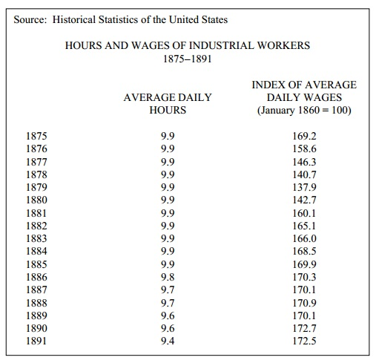

Document 2
Source: Editorial, The New York Times, July 18, 1877

. . . [T]he strike is apparently hopeless, and must be regarded as nothing more than a rash and spiteful demonstration of resentment by men too ignorant or too reckless to understand their own interests. . . . But if the strike on the Baltimore and Ohio Road is a foolish one, its history up to the present time shows that those who are engaged in it are not only bold and determined, but that they have the sympathy of a large part of the community in which they live. . . .

Document 3
Source: Western Union Telegraph Company employee contract, 1883

I, [name] of [city] in consideration of my present reemployment by the Western Union Telegraph Co. hereby promise and agree to and with the said company that I will forthwith abandon any and all membership, connection or affiliation with any organization or society, whether secret or open, which in anywise attempts to regulate the conditions of my services or the payment thereof while in the employment now undertaken. I hereby further agree that I will, while in the employ of said company, render good and faithful service to the best of my ability, and will not in anywise renew or re-enter upon any relations or membership whatsoever in or with any such organizations or society.

Dated . . . . . 1883.
Signed . . . . . Address . . . . . (Seal)
Accepted for the Western Union Telegraph Co. . . . . . , Superintendent

Document 4
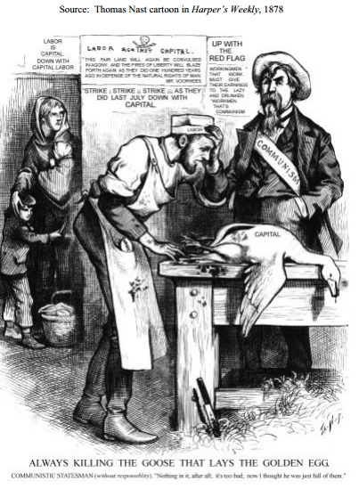

Document 5
Source: The testimony of a machinist before the Senate Committee on Labor and Capital, 1883

Question: Is there any difference between the conditions under which machinery is made now and those which existed ten years ago?
Answer: A great deal of difference.

Question: State the differences as well as you can.
Answer: Well, the trade has been subdivided and those subdivisions have been again subdivided, so that a man never learns the machinist's trade now. Ten years ago he learned, not the whole of the trade, but a fair portion of it. In the case of making the sewing-machine, for instance, you find that the trade is so subdivided that a man is not considered a machinist at all. In that way machinery is produced a great deal cheaper than it used to be formerly, and in fact, through this system of work, 100 men are able to do now what it took 300 or 400 men to do fifteen years ago.

Document 6
Source: Testimony of Samuel Gompers before a commission established by the House of Representatives
on the Relations and Conditions of Capital and Labor, 1899

The working people find that improvements in the methods of production and distribution are constantly being made, and unless they occasionally strike, or have the power to enter upon a strike, the improvements will all go to the employer and all the injuries to the employees. . . . The American Republic was not established without some suffering, without some sacrifice, and no tangible right has yet been achieved in the interest of the people unless it has been secured by sacrifices and persistency.

document 7
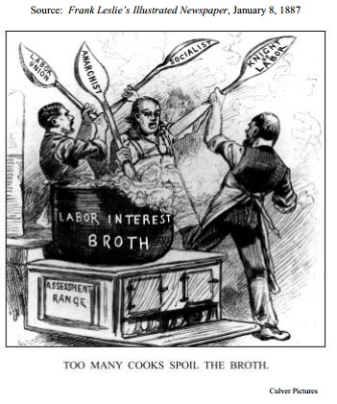

Document 8
Source: Coroner's list of the killed, Pittsburgh, Pennsylvania, July 7, 1892 (The New York Times, July 8, 1892)

The following are the names of those killed yesterday as furnished by the Coroner:
J. W. KLINE, Pinkerton detective, of Chicago
JOSEPH SOTAK, a striker of Homestead
PETER FERRIS, a laborer at the Homestead plant
SILAS WAIN of Homestead, who was watching the battle from the mill yard
JOHN E. MORRIS, employed in the steel works at Homestead
THOMAS WELDON of Homestead
EDWARD CONNORS, a Pinkerton detective of New York
BORITZ MARKOWISKY of Homestead
PETER HEISE of Homestead
ROBERT FOSTER of Homestead
WILLIAM JOHNSON of Homestead

A number of others are reported dead, but the Coroner has no official notification of their death.
Unit 6: The Gilded Age
DBQs
- (2012) #1: Explain the major political and economic causes and consequences for the growth of big business in American society from 1870 to 1900.

- (2007) #1 (a): Evaluate the extent to which advances in agriculture contributed to maintaining continuity as well as fostered change within American society during the period from 1865 to 1900.

- (2007) #1 (b): Evaluate the causes which led to the agricultural changes within American society during the period from 1865 to 1900.

- (2000) #1 (a): Evaluate the extent to which organized labor contributed to maintaining continuity as well as fostered change in American society from 1875 to 1900.

- (2000) #1 (b): Compare and contrast the goals and strategies of organized labor unions from 1875 to 1900.

Long Essays
- (2009B) #4: Explain the origins of third parties and their effects on United States politics and national policies after 1877.

- (2009B) #4: Explain the origins of The Populist Party (1892) and its effects on United States politics and national policies.

- (2006B) #4: Evaluate the extent to which the American West was a land of opportunity for various groups from 1865 to 1890.

- (2003B) #4: Evaluate the ways that farmers and industrial workers responded to industrialization in the Gilded Age (1865 to 1900).

- (2002B) #3: Explain how industrialization and migration triggered a major change in American cities in the second half of the 19th century.

- (2001) #4: Evaluate the extent to which transportation developments spark economic growth contributed to maintaining continuity as well as fostered change in American society from 1860 to 1900.

- (1999) #3: Explain the extent to which the lives of the American Indians were impacted by western settlement from 1865 – 1898.

Unit 6: The Gilded Age
Short Answer Questions

- Answer a, b, and c. (AMSCO15)
  - Briefly explain the role of ONE of the following n the Republican Party during this period

    - Spoilsmen
    - “waving the bloody shirt”
    - Tariffs

  - Briefly explain the effects of ONE of the following on business and government during this period

    - Credit Mobilier
    - Tweed Ring
    - Panic of 1873

  - Briefly explain the significance of ONE of the following in terms of President Grant’s administration

    - Jay Gould
    - Horace Greeley
    - Rutherford B. Hayes

“An electric light man met with a horrible death at the corner of Centre and Chambers streets… he died on a network of wires, in mid-air, while the deadly fluid actually made his body sizzle and blood poured out on the sidewalks and over the cloths of the horrified spectators… The man’s body lay limp and motionless over the mass of wires attached to the crosstrees of the poles… every few seconds the blue flames spurted out from various parts of his body. Hundreds of people stood shivering as they looked at the awful sight overhead. No one dared to go near; even the firemen’s faces blanched with horror.
“Immediately after the accident Mayor Grant was notified. The mayor gave orders that the wires which caused the accident to be cut at once. His secretary said the mayor would act promptly in the matter and it is possible he may order the cutting of all electric light wires above ground, tonight whereupon a large part of the city will be in darkness.”
-Aspen Weekly Times, Colorado, October 12, 1889

- Using the excerpt, answer a, b, and c. (AMSCO16)
  - Briefly explain ONE reason why the death of linemen in New York City became a national news event at the time.
  - Briefly identify and explain ONE other innovation of this era from 1865 to 1900 that had both positive and negative impacts on American society at the time.
  - Briefly analyze ONE way the problems in this excerpt resulted in an increased role for city governments.

- Complete the following three tasks:
  - Identify THREE different challenges that farmers contended with from 1875 to 1900.
  - Explain how ONE of the examples from Part A impacted the condition of farmers.
  - Explain ONE 20th-century impact of the challenge explained in Part B on U.S. government policy or American society.

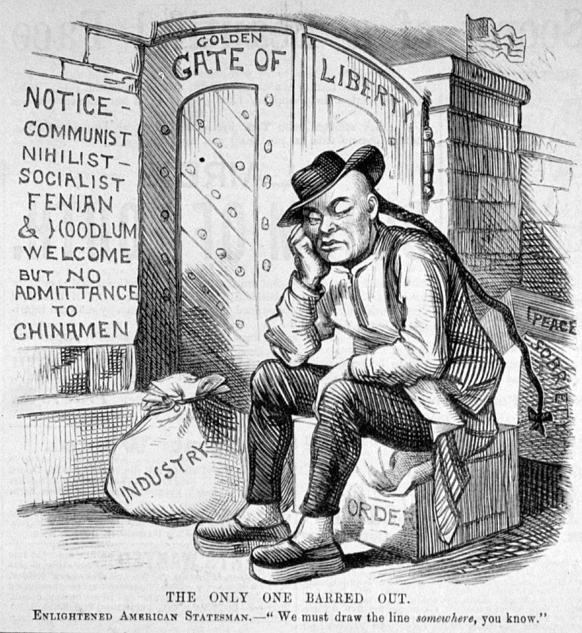
- Using the cartoon, answer a and b. (AMSCO18)
  - Briefly explain the illustrator’s point of view on immigration expressed in the political cartoon.
  - Briefly explain TWO federal immigration policies or actions taken during the late 19th century, and whether each supported or opposed the point of view in the cartoon.

- During the years 1870 to 1900, labor and management battled for control over wages and working conditions. (SurvivalGuide-SAQ)
  - Explain ONE governmental policy or practice that contributed to this conflict.
  - Explain ONE cultural or intellectual movement that contributed to this conflict.
  - Provide ONE new piece of outside evidence and explain how it supports your response in either Part A or Part B.

- Government support for big business created discontent among workers and farmers in the late nineteenth century. (FastTrackCH12)
  - Which of the following government actions did the most to counter the idea that the government existed to support and promote big business? Provide at least ONE piece of historical evidence in your explanation.

    - Sherman Anti-Trust Act
    - Munn v. Illinois
    - Interstate Commerce Act

  - Choose one other action from the list. Why was the act/decision more beneficial to those oppressed by big business? Support your answer with historical evidence.
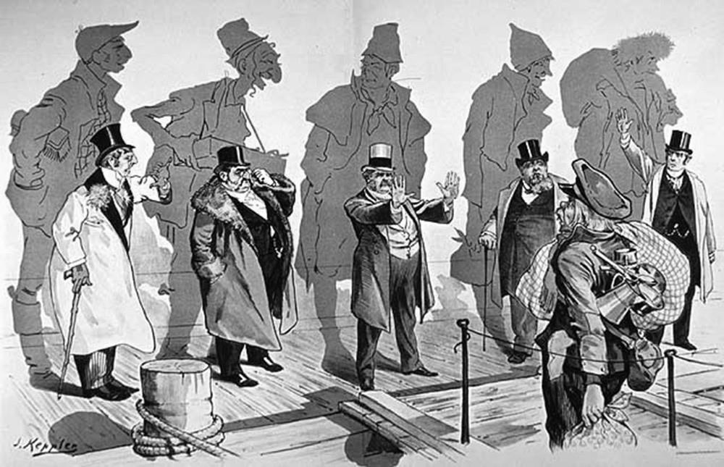
- Using the cartoon published in 1893, answer a, b, and c. (FastTrack#2)
  - Briefly explain the message intended by the cartoonist.
  - Provide ONE piece of evidence from American history that would have motivated the cartoonist to create this image.
  - Explain ONE reason for the increase in immigration in the 1890s.

This question is based on the following two passages.
“The promise of freedom and prosperity seemed to have been revoked for those who labored, as opposed to those who owned and managed the nation’s resources and industrial enterprises. Fundamental decisions about their lives—from whether they worked and for how much, to whose influence would shape their control. Pain and bewilderment led to outrage and action. Unionizing workers called for “industrial democracy,” Populist farmers for a “cooperative commonwealth.” Indeed, if corporate capitalists saw themselves as champions of a free market version of American democracy, organized labor and other advocates for the poor and dispossessed saw themselves as vindicating an egalitarian version of that same democracy.”
Francis G. Couvares, et. al., “The Triumph of Capitalism: Efficiency or Class War?” 2009

“From the beginning, it seems, businessmen have run the American economy. They can take the credit and the blame for many of its achievements and failures. They, more than [any] other group in the economy, have managed the production, transportation, and distribution of goods and services. No other group—farmers, blue-collar workers, or white-collar workers—has ever had much to do with the overall coordination of the economic system or its adaptation to basic changes in the population and technology.…In the past, businessmen have devoted their energies to economic affairs, giving far less attention to cultural, social, or even political matters. Precisely, because they have created an enormously productive economy and the most affluent society in the world…”
Alfred D. Chandler Jr., The Role of Business in the United States: A Historical Survey, 1969

- Based on the two interpretations above regarding late 19th-century industrialization, complete the following three tasks: (SurvivalGuide-SAQ)
  - Briefly explain the main point made in Passage 1.
  - Briefly explain the main point made in Passage 2.
  - Provide ONE piece of evidence from 1865 to 1900 that is not included in the passages, and explain how it supports or refutes the interpretation of either passage.
- Several unions were founded and grew in the second half of the nineteenth century in response to issues workers faced as the nation industrialized. The union had different philosophies, goals, and memberships. (FastTrackCH11)
  - Choose ONE of the following unions below and describe their union’s membership, philosophy, and tactics.

    - American Federation of Labor
    - Knights of Labor
    - Industrial Workers of the World (Wobblies)

  - Why might this union have a better chance of accomplishing its goals than other unions? Provide at least ONE example in comparison.

- Answer (a), (b), and (c). (APUSH2015)
  - Briefly explain why ONE of the following best marks the beginning of industrialization in the United States.
    - The market revolution in the first half of the 1800s
    - The Civil War era in the middle of the 1800s
    - The rise of big business in the second half of the 1800s
  - Provide ONE example of an event or development that supports your explanation in (a).
  - Provide specific historical evidence that explains why ONE of the other options is less convincing as the possible beginning of industrialization in the United States.

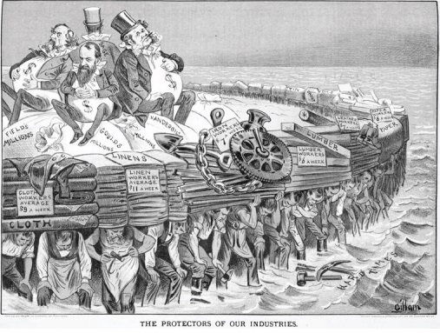
- Using the 1883 image above, answer a, b, and c. (ExamDescription)
  - Briefly explain the point of view about the economy expressed by the artist.
  - Briefly explain ONE development in the period 1865 to 1910 that could be used to support the point of view expressed by the artist.
  - Briefly explain ONE development in the period 1865 to 1910 that could be used to challenge the point of view expressed by the artist.

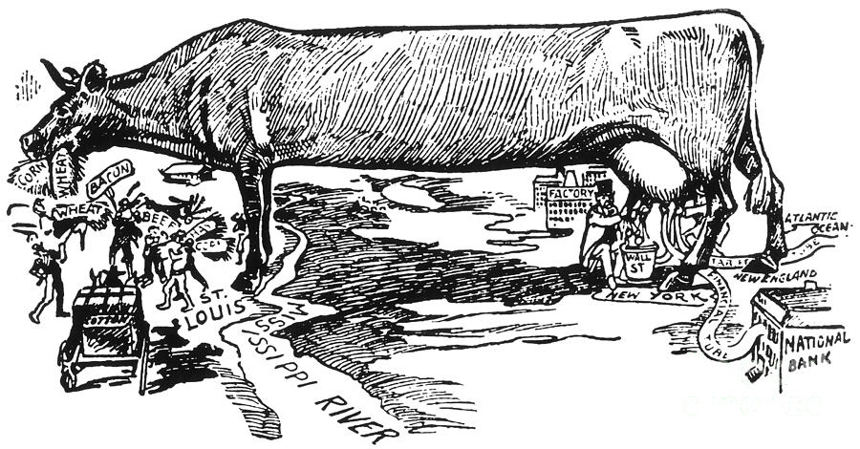
- Using the cartoon, answer a, b, and c. (AMSCO19)
  - Briefly explain the point of view of the artist about ONE of the following:
    - Western Farmers
    - New York’s Wall Street
  - Briefly explain ONE development in the period from 1865 to 1900 that supported the point of view of the artist.
  - Briefly explain ONE development in the period from 1865 to 1900 that challenged the point of view expressed by the artist.

"[W]e have in [United States history] a recurrence of the process of evolution in each western area reached in the process of expansion. Thus American development has exhibited not merely advance along a single line, but a return to primitive conditions on a continually advancing frontier line, and a new development for that area. American social development has been continually beginning over again on the frontier. This perennial rebirth, this fluidity of American life, this expansion westward with its new opportunities, its continuous touch with the simplicity of primitive society, furnish the forces dominating American character. The true point of view in the history of this nation is not the Atlantic coast, it is the Great West. . . . In this advance, the frontier is the outer edge of the wave —the meeting point between savagery and civilization."
Frederick Jackson Turner, historian, "The Significance of the Frontier in American History," 1893

"[T]he history of the West is a study of a place undergoing conquest and never fully escaping its consequences. . . . Deemphasize the frontier and its supposed end, conceive of the West as a place and not a process, and Western American history has a new look. First, the American West was an important meeting ground, the point where Indian America, Latin America, Anglo-America, Afro-America, and Asia intersected. . . . Second, the workings of conquest tied these diverse groups into the same story. Happily or not, minorities and majorities occupied a common ground. Conquest basically involved the drawing of lines on a map, the definition and allocation of ownershippersonal, tribal, corporate, state, federal, and international, and the evolution of land from matter to property."
Patricia Nelson Limerick, historian, The Legacy of Conquest: The Unbroken Past of the American West, 1987

- Using the excerpts above, answer parts a, b, and c. (APUSH2014)
  - Briefly explain ONE major difference between Turner's and Limerick's interpretations.
  - Briefly explain how someone supporting Turner's interpretation could use ONE piece of evidence from the period between 1865 and 1898 not directly mentioned in the excerpt.
  - Briefly explain how someone supporting Limerick's interpretation could use ONE piece of evidence from the period between 1865 and 1898 not directly mentioned in the excerpt.

They were aggressive men, as were the first feudal barons; sometimes they were lawless; in important crises, nearly all of them tended to act without those established moral principles which fixed more or less the conduct of the common people of the community. . . . These men were robber barons as were their medieval counterparts, the dominating figures of an aggressive economic age. . . . Under their hands, the renovation of our economic life proceeded relentlessly; large-scale production replaced the scattered, decentralized mode of production; industrial enterprises became more concentrated, more 'efficient' technically, and essentially 'cooperative,' where they had been purely individualistic and lamentably wasteful."
Matthew Josephson, historian, 1934

"What really lifted the giants above the rest was the ability to envision where the world, or their part of it, was going, and to act on that vision in a creative way. . . . From the days of Adam Smith, self-interest has been the acknowledged driving force of capitalism; the secret of the market system is that one person's self-interest can simultaneously serve the interests of others. Buyers and sellers, producers and consumers, investors and entrepreneurs take reciprocal advantage of each other. Success rewards those who can discover or create areas of reciprocity; the larger the area, the greater the success. . . . They were captains of industry; but like officers of volunteer regiments, they held their posts at the sufferance of those they led."
H. W. Brands, historian, 1999

- Using the excerpts, answer (a), (b), and (c). (APUSH2016)
  - Briefly explain ONE major difference between Josephson's and Brands's historical interpretations of business leaders who rose to prominence between 1865 and 1900.
  - Briefly explain how ONE person, event, or development from the period 1865-1900 that is not explicitly mentioned in the excerpts could be used to support Josephson's interpretation.
  - Briefly explain how ONE person, event, or development from the period 1865-1900 that is not explicitly mentioned in the excerpts could be used to support Brands's interpretation.

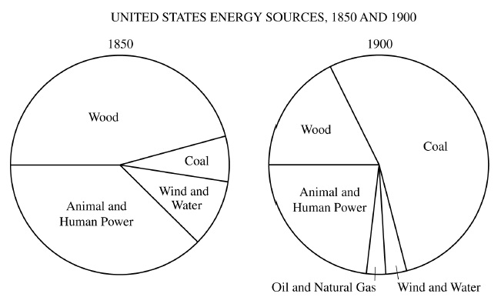
- Using the pie charts above, answer a, b, and c. (APUSH2016-International)
  - Briefly explain ONE specific historical event or development that accounts for the changes in United States energy sources between 1850 and 1900.
  - Briefly explain ONE specific historical effect of the changes in United States energy sources between 1850 and 1900.
  - Briefly explain a SECOND specific historical effect of the changes in United States energy sources between 1850 and 1900.

