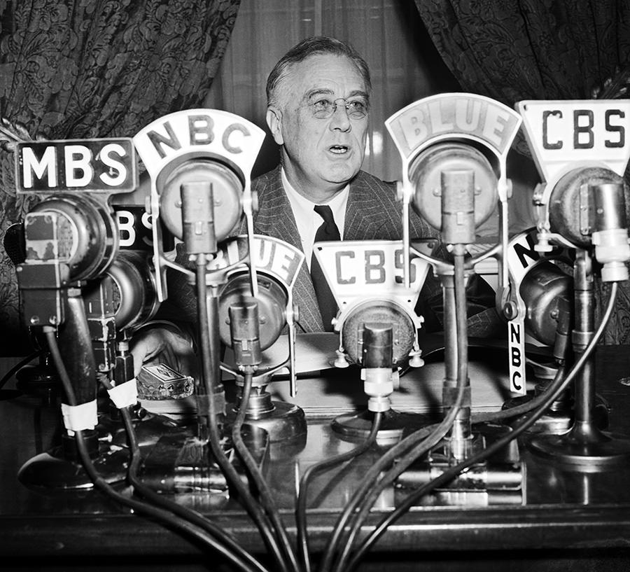 | THE HISTORY HERALD  April 13th , 2020  11th Grade APUSH  www.MrDuncansHistoryClass.com | 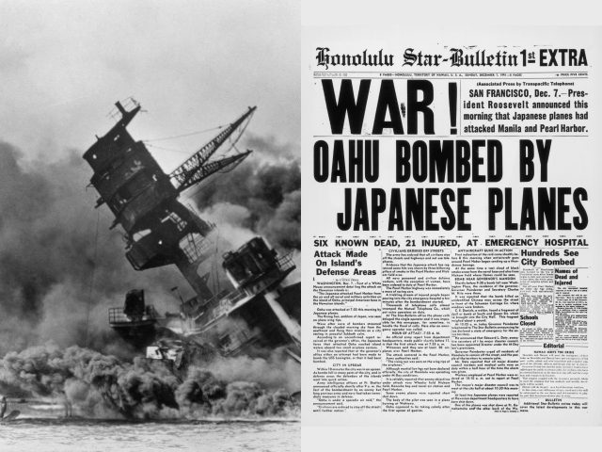
THIS WEEK  Mon 13th Online Lecture New Deal Watch video on DBQs  Tues 14th ZOOM MEETING 10am Finish the New Deal  Wed 15th FIRST DBQ PRACTICE DUE  Thurs 16th ZOOM MEETING 10am DBQ and WWII Home Front  Fri 17th Online Lecture WWII General Knowledge  ONLINE TEST 1920s and 1930s Open Thursday to Sunday  Next week the Truman, the Cold War, 1950s  CHAPTER 32  Franklin D. Roosevelt and the Shadow of War, 1933–1941  focus questions  1. What were the main characteristics of Roosevelt’s foreign policy and why was the American public bent on isolationism during the 1930s?  2. What were the steps that America took to try and remain neutral as Europe headed into World War II?  3. What steps did Germany and Japan take to lead America into the European conflict?  Chapter Theme  Theme: In the early and mid-1930s, the United States attempted to isolate itself from foreign involvements and wars. But by the end of the decade, the spread of totalitarianism and war in Europe forced Roosevelt to provide more and more assistance to desperate Britain, despite strong isolationist opposition.  chapter summary  Roosevelt’s early foreign policies, such as wrecking the London economic conference and establishing the Good Neighbor policy in Latin America, were governed by concern for domestic recovery and reflected America’s desire for a less active role in the world. America virtually withdrew from all European affairs, and promised independence to the Philippines as an attempt to avoid Asian commitments.  Depression-spawned chaos in Europe and Asia strengthened the isolationist impulse, as Congress passed a series of Neutrality Acts designed to prevent America from being drawn into foreign wars. The United States adhered to the policy for a time, despite the aggression of Italy, Germany, and Japan. But after the outbreak of World War II in Europe, Roosevelt began to provide some aid to the Allies.  After the fall of France, Roosevelt gave greater assistance to desperate Britain in the destroyers-for-bases deal and in lend-lease. Still-powerful isolationists protested these measures, but Wendell Willkie refrained from attacking Roosevelt’s foreign policy in the 1940 campaign.  Roosevelt and Winston Churchill issued the Atlantic Charter, and by the summer of 1941, the United States was fighting an undeclared naval war with Germany in the North Atlantic. After negotiations with Japan failed, the surprise attack on Pearl Harbor plunged the United States into World War II.  CHAPTER 33 America in WW II, 1941–1945  focus questions  1. How was America transformed from a peacetime to a wartime economy? What were the steps that America took to mobilize for their war with the Axis powers?  2. What was the impact of the war on domestic America?  3. What was America’s strategy for winning the war against the Axis powers?  4. What turned the tide of the war in the Pacific for American troops?  5. How did World War II end and what were the terms of settlement?  Chapter Themes  Theme: Unified by Pearl Harbor, America effectively carried out a war mobilization effort that produced vast social and economic changes within American society.  Theme: Following its “get Hitler first” strategy, the United States and its Allies invaded and liberated conquered Europe from Fascist rule. The slower strategy of island-hopping against Japan also proceeded successfully until the atomic bomb brought a sudden end to World War II.  chapter summary  America was wounded but roused to national unity by Pearl Harbor. Roosevelt settled on a fundamental strategy of dealing with Hitler first, while doing just enough in the Pacific to block the Japanese advance.  With the ugly exception of the Japanese-American concentration camps, World War II proceeded in the United States without the fanaticism and violations of civil liberties that occurred in World War I. The economy was effectively mobilized, using new sources of labor such as women and Mexican braceros. Numerous African Americans and Indians also left their traditional rural homelands and migrated to war-industry jobs in the cities of the North and West. The war brought full employment and prosperity, as well as enduring social changes, as millions of Americans were uprooted and thrown together in the military and in new communities across the country. Unlike European and Asian nations, however, the United States experienced relatively little economic and social devastation from the war.  The tide of Japanese conquest was stemmed at the Battles of Midway and the Coral Sea, and American forces then began a slow strategy of island hopping toward Tokyo. Allied troops first invaded North Africa and Italy in 1942–1943, providing a small, compromise second front that attempted to appease the badly weakened Soviet Union as well as the anxious British. The real second front came in June 1944 with the D-Day invasion of France. The Allies moved rapidly across France, but faced a setback in the Battle of the Bulge in the Low Countries.  Meanwhile, American capture of the Mariana Islands established the basis for extensive bombing of the Japanese home islands. Roosevelt won a fourth term as Allied troops entered Germany and finally met the Russians, bringing an end to Hitler’s rule in May 1945. After a last round of brutal warfare on Okinawa and Iwo Jima, the dropping of two atomic bombs ended the war against Japan in August 1945. |  | Chapter 32 and 33  Word List  1.Cordell Hull  2.Joseph Stalin  3.Benito Mussolini  4.Adolf Hitler  5.Francisco Franco  6.Winston Churchill  7.Charles Lindbergh  8.Wendell Willkie  9.totalitarianism  10.isolationism  11.appeasement  12.London Economic Conference  13.Good Neighbor policy  14.Reciprocal Trade Agreement Act  15.Nazi party  16.Rome-Berlin axis  17.invasion of Ethiopia  18.“merchants of death”  19.Neutrality Acts  20.Spanish Civil War  21.China incident  22.“Quarantine Speech”  23.Hitler-Stalin nonaggression pact  24.“cash-and-carry”  25.“phony war”  26.Committee to Defend America by Aiding the Allies  27.America First Committee  28.destroyers-for-bases deal  29.lend-lease  1.Henry Stimson  2.A. Philip Randolph  3.Douglas MacArthur  4.Chester W. Nimitz  5.Dwight D. Eisenhower  6.Joseph Stalin  7.Jiang Jieshi  (Chiang Kai-shek)  8.Thomas E. Dewey  9.Harry S. Truman  10.Albert Einstein  11.War Production Board  12.Office of Price Administration  13.WAACs  14.”Rosie the Riveter”  15.braceros  16.Fair Employment Practices Commission  17.Casablanca Conference  18.second front  19.Teheran Conference  20.D-Day  21.Battle of the Bulge  22.Potsdam Conference  23.Manhattan Project

